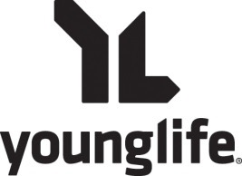

Camp Scholarship Application 2017

Through the generous donation of people who love YL we have established a Scholarship Fund. This fund is designated without regards to race, religion or Young Life involvement. It is intended for a student who is attending Young Life Camp for the first time. You may apply for as much as you need. Young Life will make every effort to see that you are able to go on this trip. If more funds are needed or if you would like, we do offer payment plans that extend through the end of the summer.

Student’s Name: Your Name:

Student’s School:

Your address:

Dates of camp: Student’s year in school:

Student’s age: School:

Parent’s signature (electronic OK):______________________________________________________

Email address:

Amount of camp scholarship money for which you are applying $ ___________________

Amount of money that you and/or your family can reasonably pay $ __________________ / with payments

Amount you have or hope to have raised through our fundraisers $ __________________

A brief statement about your involvement in Young Life (if any), why you want to attend camp this year and why you will need help in raising the needed funds.

Once Form is Completed, Call or Email Erin Horne, erinhatcher@gmail.com or Mobile: (757) 708-8959

*You can also turn in form to Assistant Principal Allen at Paxon

Parents have Questions? Call Erin Horne, Mobile: (757) 708-8959

