Salvation Army Holiday Assistance Program 2016
Holiday Hotline 904-301-4791

Thanksgiving assistance includes groceries typical for a Thanksgiving meal based on family size

Christmas assistance includes at least a gift, outfit, and stocking for children of qualified families for our Angel Tree program up to 12 years of age.

Qualifying Income Criteria
In order to qualify, applicants must meet at least one of the following income criteria:
Household Size | Annual Income | Monthly Income
1 | $15,444 | $1,287
2 | $20,826 | $1,736
3 | $26,208 | $2,184
4 | $31,590 | $2,633
5 | $36,972 | $3,081
6 | $42,354 | $3,530
7 | $47,749 | $3,890
8+ |  | Add 450 each addt’l person
- At least one adult member of the household is employed or became unemployed in the last 12 months.
- Receiving unemployment benefits, A qualifying adult receiving (SSI) supplemental security income, (SSDI) disability benefits, retirement pension, or foster care aid.
OR Currently enrolled full time student.
AND applicant must not exceed the 2016 30%
below median income guidelines listed

To Apply: You must bring the following documents:
- Picture I.D. for all adults in household
- Last 4 digits of social security number required for all household members
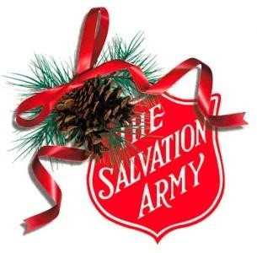
- Birth certificates for all children (age 18 and under). Or legal proof of custody.

- Verification of all household income which can include: TANF, SNAPS, child support and see qualifying income criteria- last 3 consecutive pay stubs, social security/disability award letters, unemployment benefits statement, school tuition letter, etc. A self-employed individual must provide completed tax returns from previous year.

- Verification of all household expenses: utilities bill with service address, car insurance, car note, utility allowance, medical bills, etc.

- Proof of residency: lease, deed, or mortgage statement

- If you are living with family/friends and you are not on the lease, you must still meet the qualifying income criteria, and present a notarized letter from the person on the lease that states the named individuals living with them (include address and rent charged, if any) In addition, you must provide incoming mail to verify address, if utility bill cannot be attained.

Application Dates & Times:
Please make sure you meet the income criteria and bring with you the required documents listed above.

Salvation Army Social Services 900 W Adams Street
THANKSGIVING
Monday – Friday October 3st - October 14th 9a.m. -11:30 a.m.
9a.m.- 11:30 a.m.
CHRISTMAS
Monday – Friday October 3st - October 31st 9a.m. -11:30 a.m.
Saturday October 22nd 9a.m.- 11:30 a.m.

