Daniel Memorial’s Full Service Site Presents:
School Based Groups
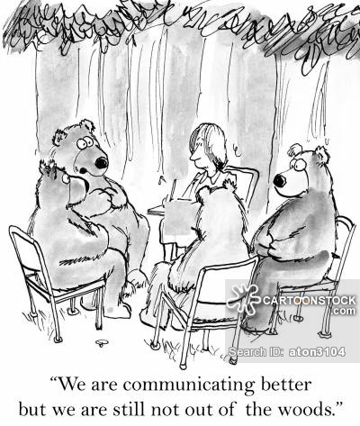
Registration Form:
Group Topic:_________________________________________________
Name:____________________________________ Date: _______________________ DOB:____________________________

2A Teacher’s Name: _______________________________ 6B Teacher’s Name: _______________________________

Last 4 digits of SS#:___________________ School: __________________________________________

Student ID#:___________________________ Grade:__________________ Age:______________________

Race:_________________________________ Gender:_________________

Street Address:_______________________________________________________________________________________________

Parent’s Email Address:________________________________________________________________________________________

City:________________________________ State:_________________________ Zip:________________________

Phone #: _______________________________ Legal Guardian name:________________________________________________

Parent Permission: I give permission for my child, ____________________________________________ to participate in the
identified group above at school. Please understand students MUST participate in the group for four sessions,
per our grant policies and procedures.

____________________________________________ _________________________________________________
Print Name Signature

Group Topics:
Goals of Anger Management Group:
~ To learn about anger styles and to become aware of personal anger triggers.
~ To learn emotions that are often masked over as anger.
~ To learn what one has control over and how to cope with what one does not.
~ To learn strategies to cope with stress, frustration, and anger.
~ To learn and practice positive communication skills and problem solving strategies.
Goals of Stress Management Group:
~Understand how stress affects an individual’s health and well-being.
~Identify and understand what creates stress for each individual.
~Identify why each individual wants to reduce stress.
~Develop short and long term goals to reduce stress.
~Identify healthy outlets to release stress.
~Develop and utilize coping skills that effectively manage identified stress.
Goals of Grief Group:
~ Understand and identify stages of grief.
~ To learn emotions that are often associated with grief.
~ To work on remembering and saying good bye to loved ones.
~ To learn strategies to cope with and process feelings of grief.
~ To learn to express and communicate feelings of grief in a healthy appropriate way.
Goals of Social Skills Group:
~ Learning common social skills such as joining peers in play, sharing, taking turns, learning to loose, etc.
~ Learning social constructs such as personal space, hygiene, appropriate communication, non-verbal body language, etc.
~ Defining peer pressure and bullying and learning how both can hurt others.
~ To learn strategies to cope with bullying and peer pressure related issues.
~ To learn and practice positive communication skills and problem solving strategies with peers.
Goals of Organizational/Study Skills Group:
~ Learning time management techniques and learning the benefits of developing a daily routine.
~ Learning how to utilize aids such as calendars, clocks, planners to stay organized.
~ Learn the benefits of prioritizing homework and extra curricular activities.
~ To learn positive thinking and positive self talk to gain confidence in ability to complete work.
~ Discuss motivation, the role it plays in successful school work, and how to gain motivation.
Goals of Self Esteem Group:
~ To Elevate feelings of positive self esteem.
~ To increase social interaction, assertiveness, confidence in self, and positive thinking.
~ To build and verbalize a positive self image.
~ To increase positive social interactions and positive choices.

**Return to Ms. Clayton, in the Counseling Office, prior to your first counseling session.**

