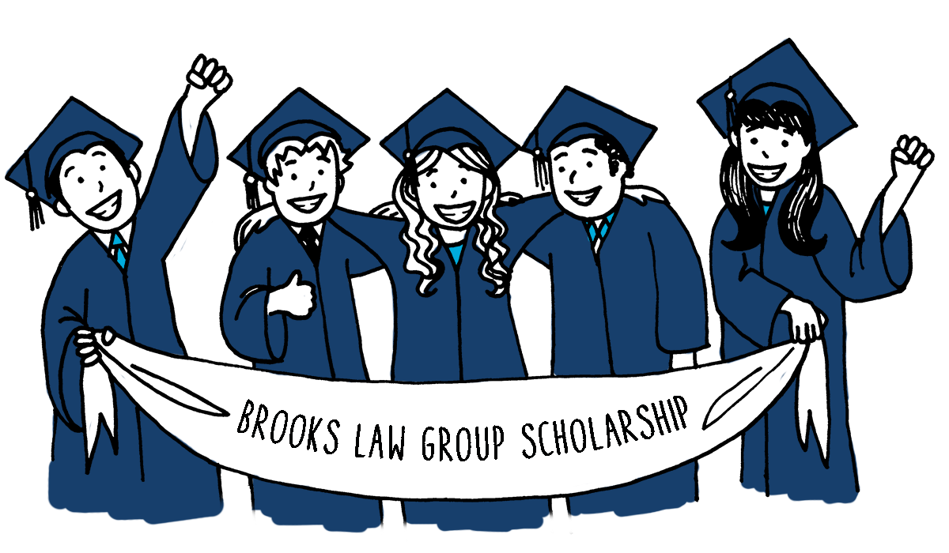
Brooks Law Group has always been passionate advocates for client rights, Whatever It Takes. As we approach our 25th year, it seems fit to reflect on the impact we have had in our community as well. The Brooks team has had a strong philanthropic culture and a heart for the community of Winter Haven as a whole. Steve and Beach Brooks grew up in this city and went to these schools. In an effort to give back, we are proud to announce the first annual Brooks Law Group Scholarship.
At Brooks Law Group, we encourage students to view their career goals in context to the community they serve. Our essay topic is designed around a concept that's important but difficult to always execute: Understanding the why behind what you do.

2017 Scholarships - Fall
  - Two (1st and 2nd place) scholarships will be awarded
  - Application Deadline: November 1st
  - Awards will be announced December 15th
First Place Winner: $ 1000
Second Place Winner: $ 250

Scholarship Essay Topics:
1) Interstate 4 (I4) has recently been named the most dangerous highway in America.
a) In your opinion, what factors do you believe lead up to its new found alias?
b) If your family was visiting from out of town and traveling I4, what advice
would you give them to make their trip as safe as possible?
2) Distracted driving is a major cause of car-related injuries and deaths.
a) What are the biggest distractions you face daily while driving?
b) Compile 5-7 steps on way to avoid distractions while driving.

Selection Process
Essays will be judged based on the following criteria:
- Correct use of grammar and language
- Well-reasoned ideas on the topic
- Demonstration of integrity
- Foundational knowledge of law

To Apply, Email:
scholarship@brookslawgroup.com

Please Include:
- A small paragraph about yourself
- How to reach you
- A digital photo of yourself to use as a headshot (jpg or png)

Timeline
Fall:
August 1st: Submissions Open
November 1st: Submissions Close
December 15th: Winners Announced

Scholarship Rules
All writing must be between 700 and 1,400 words and original to the student
Applicants must be a high school senior or current undergraduate student
Be enrolled in or planning to attend a U.S. college or university
Submit their application with all components by the deadline

Once the deadline has passed, Brooks Law Group will select the winner. Winners will be notified by email. Enrollment will be verified with the college or university before Brooks Law Group submits a one-time payment to the college or university on behalf of the winner. Upon winning, the winner's photograph and essay will be published on Brooks Law Group's Blog.
By voluntarily submitting identifiable information to our email address, you are providing Brooks Law Group with your name, phone number and email address for the sole purpose of entering the essay contest.
By taking part in this essay contest, contestants agree to indemnify, defend and hold harmless Brooks Law Group its managers, members, directors, officers, and employees from and against any and all liability and costs, including reasonable attorneys’ fees associated with taking part in this contest or the acceptance, use or of prizes. Under no circumstances shall Brooks Law Group its directors, officers and employees, be liable to the contestant for indirect, punitive, special or consequential damages.
Employees of Brooks Law Group their board of directors and immediate families are not eligible to enter this essay contest.
· PUBLICITY: Except where prohibited by law, by accepting a Scholarship Prize, Brooks Law Group Scholarship recipients agree that Brooks Law Group may, without any limitation or further compensation or notice, use his or her name, and/or likeness in any and all media, worldwide, for the purpose of advertising and promoting Brooks Law Group and the Scholarship Program.
· BROOKS LAW GROUP’S RIGHT TO MODIFY, SUSPEND OR TERMINATE. In the event Brooks Law Group is prevented from continuing with the Scholarship Program by any event beyond its reasonable control, then Brooks Law Group shall have the right in its sole discretion to modify or terminate the Scholarship Program.

**By submitting my essay to be entered into the Brooks Law Group scholarship contest, I am agreeing that any and all content submitted can be utilized by Brooks Law Group for any purpose including, but not limited to, blogs or social media posts without any attribution of authorship to myself and will become the complete and full property of Brooks Law Group. I also agree that I will not post this essay to any other website/blog/internet source, as I have given Brooks Law Group all rights to this article.**

